32 Forms of God Ganesh
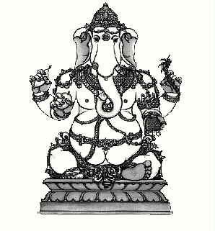
1. Bala Ganapati
- Bala Ganapati is "the Childlike" God of golden hue.

- In His hands He holds a banana, mango, sugar cane and jackfruit, all representing the earth's abundance and fertility.

- His trunk garners.

- His favorite sweet, the modaka is in his trunk.

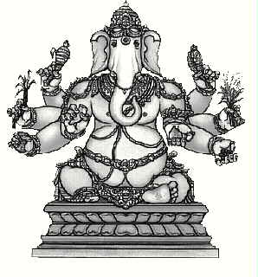
2. Taruna Ganapati
- Eight-armed, Taruna Ganapati, "the Youthful," holds a noose and goad, modaka, wood apple, rose apple.

- His broken tusk, a sprig of paddy and a sugar cane stalk.

- His brilliant red color reflects the blossoming of youth.

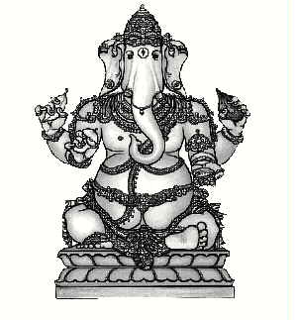
3.Bhakti Ganapati
- Shining like the full moon during harvest season and garlanded with flowers.

- Bhakti Ganapati, dear to devotees, is indeed pleasant to look upon.

- He holds a banana, a mango, coconut and a bowl of sweet payasa pudding.

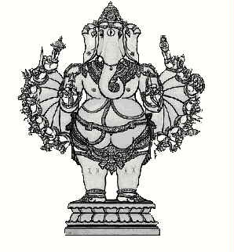
4.Vira Ganapati
- The "Valiant Warrior," Vira Ganapati, assumes a commanding pose.

- His 16 arms bristle with weapons, symbols of mind powers.

- a goad, discus, bow, arrow, sword, shield, spear, mace, a battleaxe, a trident and more.

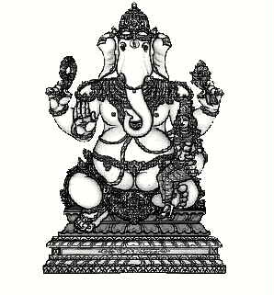
5. Shakti Ganapati
- Four-armed and seated with one of His shaktis on His knee, Shakti Ganapati, "the Powerful," of orange-red hue, guards the householder.

- He holds a garland, noose and goad, and bestows blessings with the abhaya mudra.

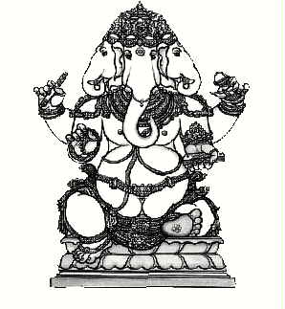
6.Dvija Ganapati
- Four-headed Dvija Ganapati, "the Twice-born," is moon-like in color.

- Holding a noose, a goad, anola leaf scripture, a staff, water vessel and a his japa beads.

- He reminds one and all of the urgency for disciplined striving.

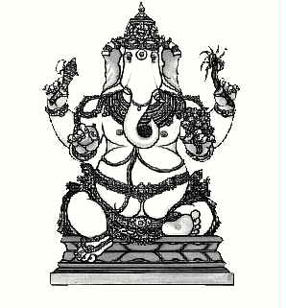
7.Siddhi Ganapati
- Golden-yellow Siddhi Ganapati, "the Accomplished," is the epitome of achievement and self-mastery.

- He sits comfortably holding a bouquet of flowers, an axe, mango, sugar cane and, in His trunk, a tasty sesame sweet.

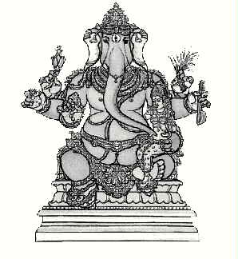
8.Ucchhishta Ganapati
- Ucchhishta Ganapati is "Lord of Blessed Offerings" and guardian of culture.
- Of blue complexion and six-armed, He sits with His Shakti, holding a vina, pomegranate, blue lotus flower, japa mala and a sprig of fresh paddy.

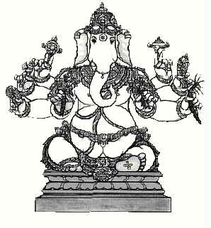
9.Vighna Ganapati
- Vighna Ganapati, "Lord of Obstacles," is of brilliant gold hue and bedecked in jewels.

- His eight arms hold a noose and goad, tusk and modaka, conch and discus, a bouquet of flowers, sugar cane, flower arrow and an axe.

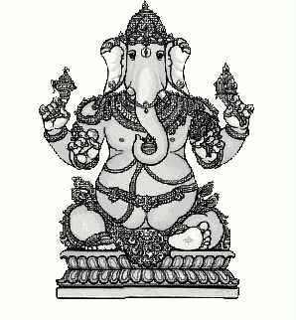
10.Kshipra Ganapati
- Handsome, red-hued Kshipra Ganapati, "Quick-acting" giver of boons, displays His broken tusk, a noose, goad and a sprig of thekalpavriksha (wish-fulfilling) tree.
- In His uplifted trunk He holds a tiny pot of precious jewels.

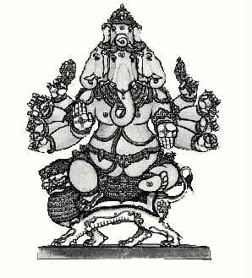
11.Heramba Ganapati
- Five-faced, white in color, Heramba Ganapati, "Protector of the Weak," rides a big lion.

- He extends the gestures of protection and blessing while holding a noose, japa beads, axe, hammer, tusk, garland, fruit and modaka.

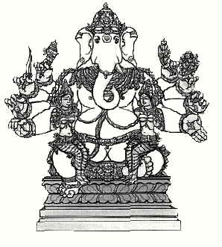
12.Lakshmi Ganapati
- Lakshmi Ganapati, pure white giver of success, sits flanked by Wisdom and Achievement.

- Gesturing varada mudra, He holds a green parrot, a pomegranate, sword, goad, noose, sprig of kalpavriksha and a water vessel.

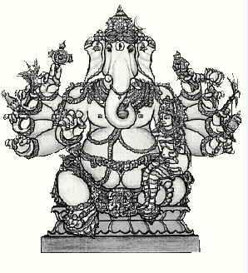
13.Maha Ganapati
- Accompanied by one of His shaktis, "the Great," Maha Ganapati, is red-complexioned and three-eyed.

- He holds His tusk, a pomegranate, blue lily, sugar-cane bow, discus, noose, lotus, paddy sprig, mace and a pot of gems.

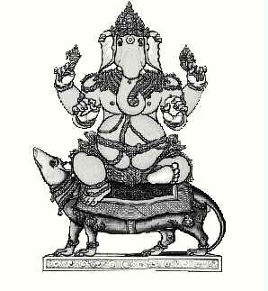
14.Vijaya Ganapati
- Four-armed, of red hue and riding His resourceful mushika, Vijaya Ganapati is "the Victorious" bestower of success.

- His insignia are the broken tusk, elephant goad, a noose and a lucious golden mango, His favorite fruit.

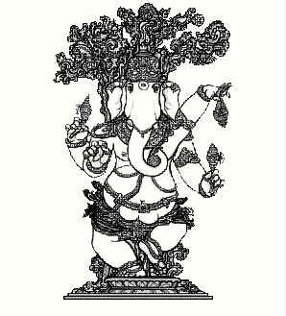
15.Nritya Ganapati
- The happy "Dancer," Nritya Ganapati, is four-armed and golden, with rings on His fingers, holding a tusk, goad, noose andmodaka sweet.

- He prances under the kalpavriksha tree, epitomizing exuberant activity and joy.

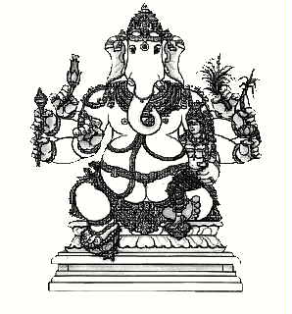
16.Urdhva Ganapati
- Seated with one of His shaktis on His left knee, Urdhva Ganapati is "the Elevated" Lord of golden hue.

- In His six hands He holds a sprig of paddy, a lotus, the sugar cane bow, an arrow, His ivory tusk and a blue water lily.

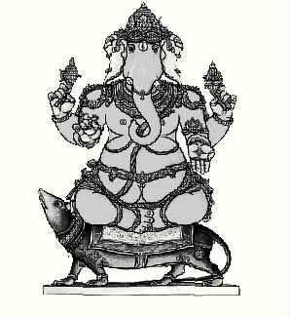
17.Ekakshara Ganapati
- Ekakshara, of "Single-Syllable"(gam), is three-eyed, of red complexion and attire.

- Crescent moon on His crown, He sits in lotus pose upon Mushika, offers the boon-giving gesture and holds a pomegranate, noose and goad.

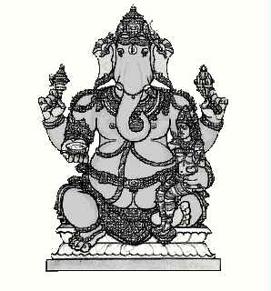
18.Varada Ganapati
- Varada Ganapati, "the Boon-Giver with prominent third eye of wisdom, holds a dish of honey, the noose and goad and encloses a pot of jewels in His trunk.

- His shakti is at His side, and the crescent moon adorns His crown.

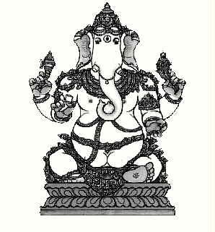
19.Tryakshara Ganapati
- Tryakshara Ganapati, "the Lord of Three Letters" (A-U-M), is gold in color and has fly whisks in His big floppy ears.

- He carries the broken tusk, goad, noose and mango and is often seen grasping a sweet modaka in His trunk.

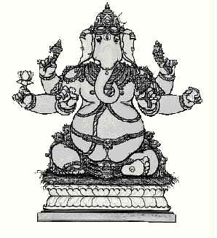
20.Kshipra Prasada Ganapati
- Kshipra Prasada Ganapati, "the Quick Rewarder," presides from akusha-grass throne.

- His big belly symbolizes the manifest universe.

- He holds a noose, goad, tusk, lotus, pomegranate and a twig of the wish-fulfilling tree.

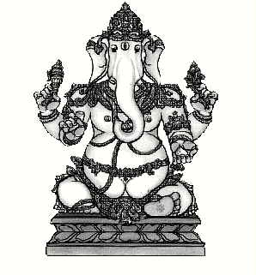
21.Haridra Ganapati
- Haridra Ganapati, the golden one dressed in bright yellow vestments, sits calmly on a posh, regal throne.

- Along with His tusk and a modaka, He wields a noose to hold devotees close and a sharp goad to spur them onward.

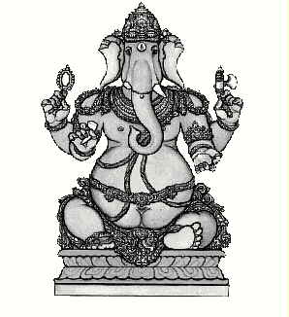
22.Ekadanta Ganapati
- Ekadanta, of "Single Tusk," is distinguished by His blue color and sizeable belly.

- The attributes of this murti are an axe for cutting the bonds of ignorance, prayer beads for japa, a laddusweet and the broken right tusk.

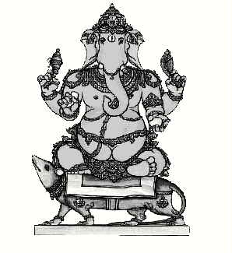
23.Srishti Ganapati
- Riding on His docile and friendly mouse, Srishti Ganapati is the lord of happy "Manifestation."

- This active God, of red complexion, holds His noose a goad, a perfect mango, and His tusk, representing selfless sacrifice.

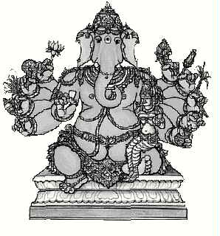
24.Uddanda Ganapati
- Uddanda Ganapati is the bold "Enforcer of Dharma," the laws of being.

- His ten hands hold a pot of gems, a blue lily, sugar cane, a mace, lotus flower, sprig of paddy, a pomegranate, noose, garland and His broken tusk.

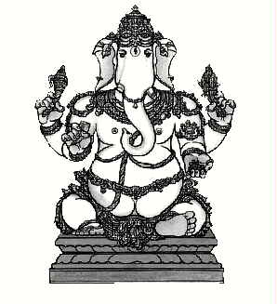
25.Rinamochana Ganapati
- Rinamochana Ganapati is humanity's liberator from guilt and bondage.

- His figure of alabaster skin is apparelled in red silks.

- He bears a noose and a goad, His milk-white tusk and a favorite fruit, the rose apple.

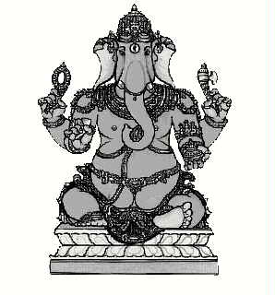
26.Dhundhi Ganapati
- Red-hued Dhundhi Ganapati, "the Sought After," holds a strand ofrudraksha beads.

- His broken tusk, an axe and a small pot of precious gems thought to represent the treasury of awakenings.

- He saves for all ardent devotees.

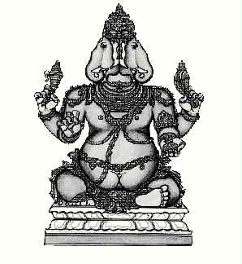
27.Dvimukha Ganapati
- Dvimukha Ganapati, called Janus by the Romans, with two divergent faces, sees in all directions.

- His blue-green form is dressed in red silk.

- He wears a bejeweled crown and holds a noose, goad, His tusk and a pot of gems.

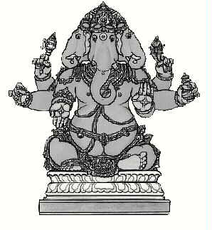
28.Trimukha Ganapati
- Trimukha Ganapati, the contemplative "three-faced" Lord of red hue, sits on a golden lotus, telling.

- His beads, holding a noose, goad and vessel of nectar.

- He gestures protection with a right hand and blessings with a left.

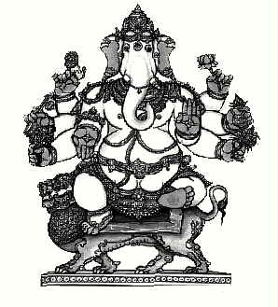
29.Sinha Ganapati
- Sinha Ganapati, white in color, rides a lion and displays another lion in one hand, symbolizing strength and fearlessness.

- He also holds a kalpavriksha sprig, the vina, a lotus blossom, flower bouquet and a pot of jewels.

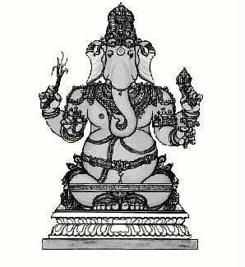
30.Yoga Ganapati
- Yoga Ganapati is absorbed in mantra japa.

- His knees strapped in meditative pose, hands holding a yoga staff, sugar cane stalk, a noose and prayer beads.

- His color is like the morning sun.

- Blue garments adorn His form.

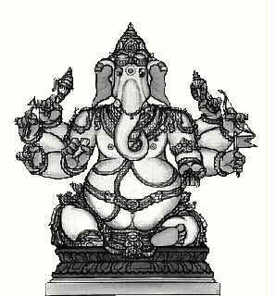
31.Durga Ganapati
- Durga Ganapati, the "Invincible," waves the flag of victory over darkness.

- This splendid murti is of deep gold hue, dressed in red, holding a bow and arrow, noose and goad, prayer beads, broken tusk and a rose apple.

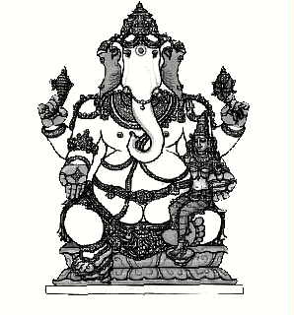
32.Sankatahara Ganapati
- Sankatahara Ganapati, "the Dispeller of Sorrow," is of sunlike hue, dressed in blue, and seated on a red lotus flower.

- He holds a bowl of pudding, a goad and a noose while gesturing the boon-granting varada mudra.

